**UML Class Diagram Relationships, Aggregation, Composition**

There are five key relationships between classes in a UML class diagram : dependency, aggregation, composition, inheritance and realization. These five relationships are depicted in the following diagram:

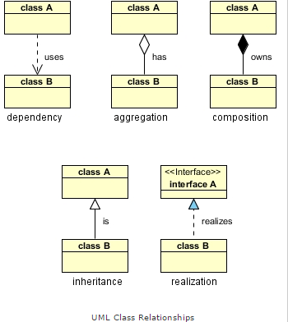

The above relationships are read as follows:

* Dependency : class A uses class B
* Aggregation : class A has a class B
* Composition : class A owns a class B
* Inheritance : class B is a Class A  (or class A is extended by class B)
* Realization : class B realizes Class A (or class A is realized by class B)